1a)Implement spanning tree protocol:

Step 1:

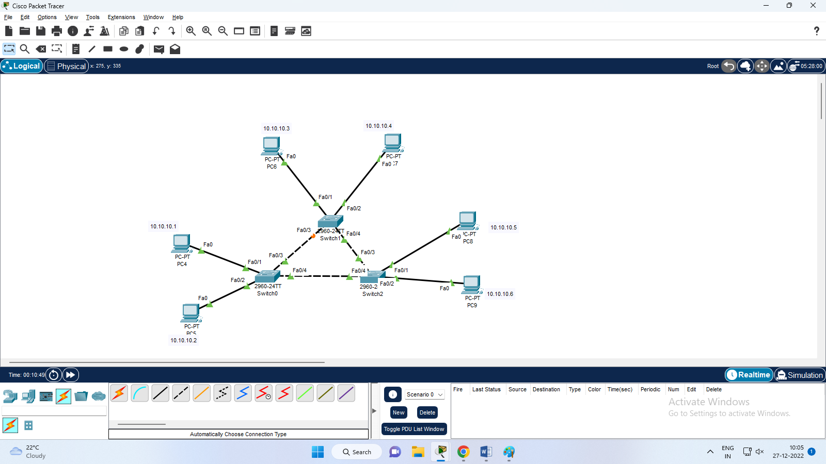

Step 2:

Switch 0:

Switch#sh spanning-tree

VLAN0001

Spanning tree enabled protocol ieee

Root ID Priority 32769

Address 0002.1670.8C10

Cost 19

Port 4(FastEthernet0/4)

Hello Time 2 sec Max Age 20 sec Forward Delay 15 sec

Bridge ID Priority 32769 (priority 32768 sys-id-ext 1)

Address 0010.1125.6107

Hello Time 2 sec Max Age 20 sec Forward Delay 15 sec

Aging Time 20

Interface Role Sts Cost Prio.Nbr Type

---------------- ---- --- --------- -------- --------------------------------

Fa0/2 Desg FWD 19 128.2 P2p

Fa0/3 Desg FWD 19 128.3 P2p

Fa0/4 Root FWD 19 128.4 P2p

Fa0/1 Desg FWD 19 128.1 P2p

Switch 1:

witch>sh spanning-tree

VLAN0001

Spanning tree enabled protocol ieee

Root ID Priority 32769

Address 0002.1670.8C10

Cost 19

Port 4(FastEthernet0/4)

Hello Time 2 sec Max Age 20 sec Forward Delay 15 sec

Bridge ID Priority 32769 (priority 32768 sys-id-ext 1)

Address 00D0.BA4E.6583

Hello Time 2 sec Max Age 20 sec Forward Delay 15 sec

Aging Time 20

Interface Role Sts Cost Prio.Nbr Type

---------------- ---- --- --------- -------- --------------------------------

Fa0/3 Altn BLK 19 128.3 P2p

Fa0/1 Desg FWD 19 128.1 P2p

Fa0/2 Desg FWD 19 128.2 P2p

Fa0/4 Root FWD 19 128.4 P2p

Switch 2:

Switch>sh spanning-tree

VLAN0001

Spanning tree enabled protocol ieee

Root ID Priority 32769

Address 0002.1670.8C10

This bridge is the root

Hello Time 2 sec Max Age 20 sec Forward Delay 15 sec

Bridge ID Priority 32769 (priority 32768 sys-id-ext 1)

Address 0002.1670.8C10

Hello Time 2 sec Max Age 20 sec Forward Delay 15 sec

Aging Time 20

Interface Role Sts Cost Prio.Nbr Type

---------------- ---- --- --------- -------- --------------------------------

Fa0/2 Desg FWD 19 128.2 P2p

Fa0/1 Desg FWD 19 128.1 P2p

Fa0/3 Desg FWD 19 128.3 P2p

Fa0/4 Desg FWD 19 128.4 P2p

**1b)Set up a network with Multi layer switch**

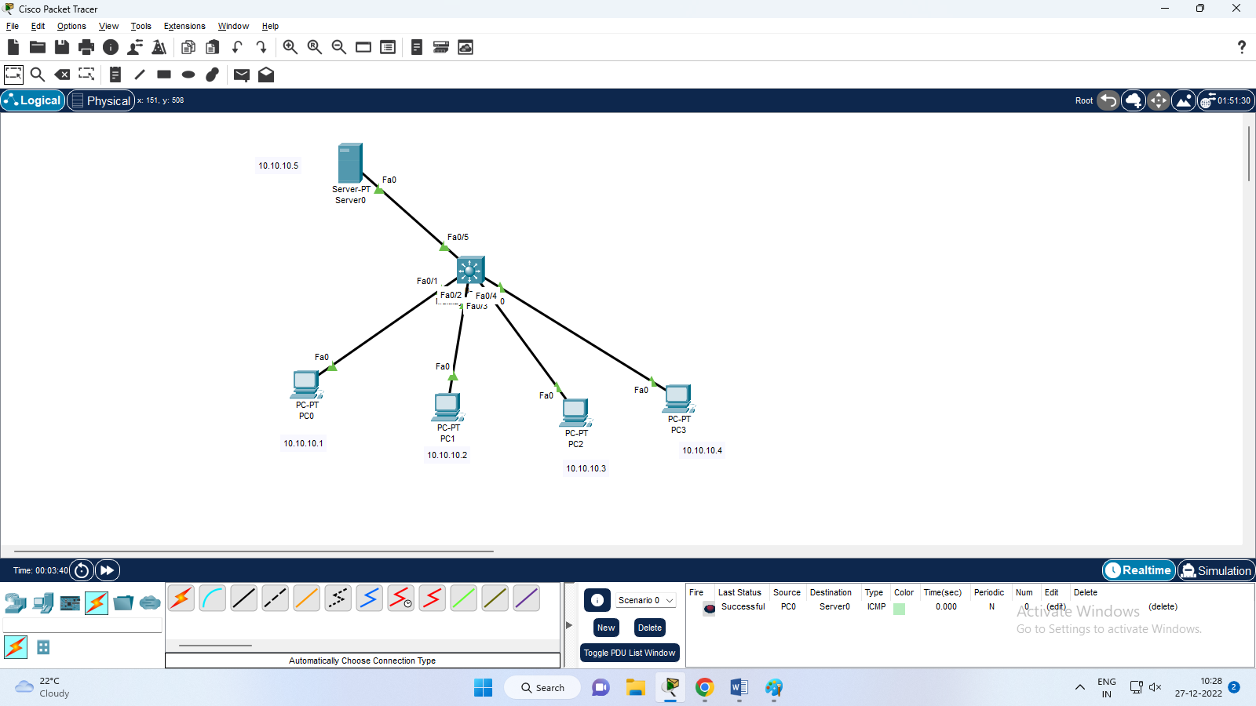

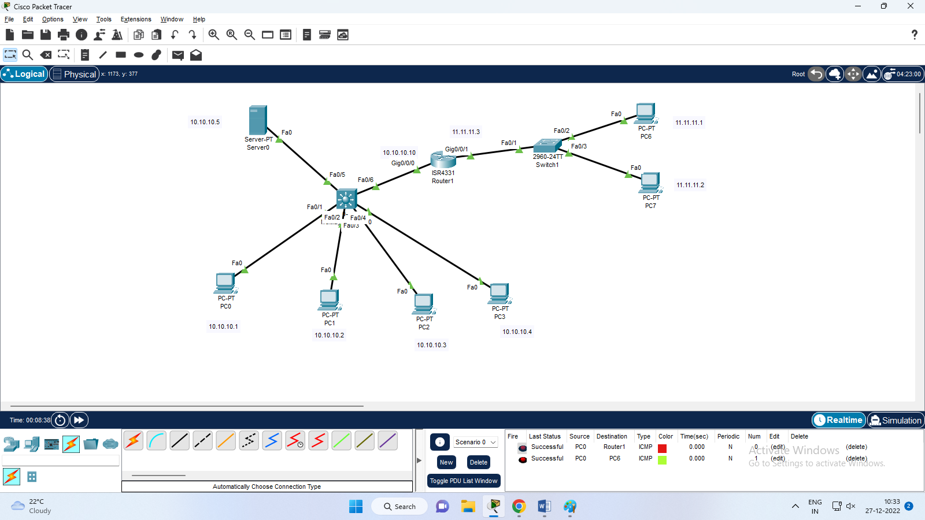

**1c)Inter vlan communication using multi layer switch**

Step 1 design the topology

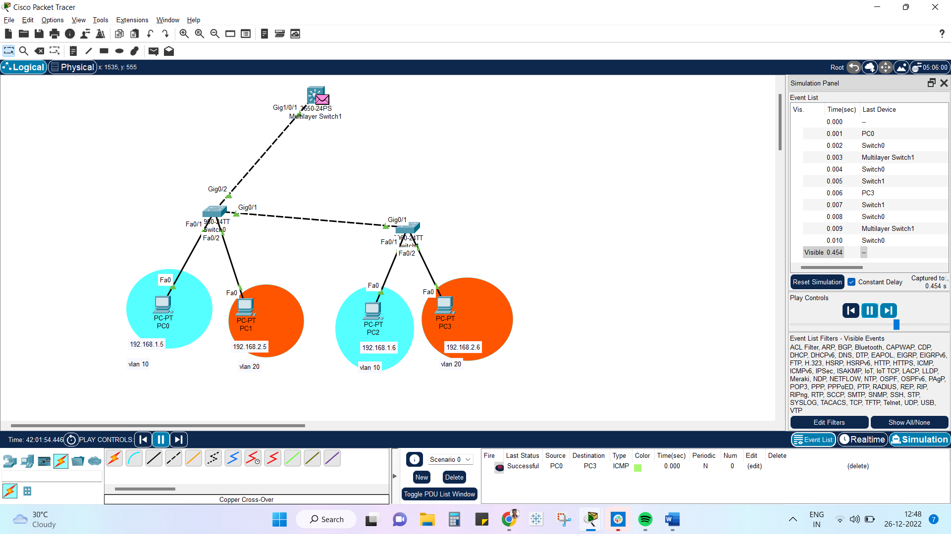

Step 2:

Do the vlan configuration

Switch 0:

Switch>en

Switch#config t

Enter configuration commands, one per line. End with CNTL/Z.

Switch(config)#vlan 10

Switch(config-vlan)#name p1

Switch(config-vlan)#exit

Switch(config)#vlan 20

Switch(config-vlan)#name p2

Switch(config-vlan)#exit

Switch(config)#int fa 0/1

Switch(config-if)#switchport mode access

Switch(config-if)#switchport access vlan 10

Switch(config-if)#int fa 0/2

Switch(config-if)#switchport mode access

Switch(config-if)#switchport access vlan 20

Switch(config-if)#exit

Switch(config)#

Switch 1:

Switch>en

Switch#config t

Enter configuration commands, one per line. End with CNTL/Z.

Switch(config)#vlan 10

Switch(config-vlan)#name p1

Switch(config-vlan)#exit

Switch(config)#vlan 20

Switch(config-vlan)#name p2

Switch(config-vlan)#exit

Switch(config)#int fa 0/1

Switch(config-if)#switchport mode access

Switch(config-if)#switchport access vlan 10

Switch(config-if)#int fa 0/2

Switch(config-if)#switchport mode access

Switch(config-if)#switchport access vlan 20

Switch(config-if)#exit

Switch(config)#

Step 3:

Trunking two switch :

Switch 0:

Switch(config)#int gig 0/1

Switch(config-if)#switchport mode trunk

Switch(config-if)#

%LINEPROTO-5-UPDOWN: Line protocol on Interface GigabitEthernet0/1, changed state to down

%LINEPROTO-5-UPDOWN: Line protocol on Interface GigabitEthernet0/1, changed state to up

Switch(config-if)#exit

Switch 1:

Switch(config)#int gig 0/1

Switch(config-if)#switchport mode trunk

Switch(config-if)#exit

Step :4

Connect the multi layer switch

Switch>en

Switch#config t

Enter configuration commands, one per line. End with CNTL/Z.

Switch(config)#vlan 10

Switch(config-vlan)#name p1

Switch(config-vlan)#exit

Switch(config)#vlan 20

Switch(config-vlan)#name p2

Switch(config-vlan)#exit

Switch(config)#int vlan 10

Switch(config-if)#ip address 192.168.1.1 255.255.255.0

Switch(config-if)#exit

Switch(config)#int vlan 20

Switch(config-if)#ip address 192.168.2.1 255.255.255.0

Switch(config-if)#exit

Switch(config)#int gig 1/0/1

Switch(config-if)#switchport mode trunk

Switch(config-if)#end

Switch#sh ip route

Default gateway is not set

Host Gateway Last Use Total Uses Interface

ICMP redirect cache is empty

Switch(config)#ip routing

Switch#wri mem

Building configuration...

Compressed configuration from 7383 bytes to 3601 bytes[OK]

[OK]

Switch#sh ip route

Codes: C - connected, S - static, I - IGRP, R - RIP, M - mobile, B - BGP

D - EIGRP, EX - EIGRP external, O - OSPF, IA - OSPF inter area

N1 - OSPF NSSA external type 1, N2 - OSPF NSSA external type 2

E1 - OSPF external type 1, E2 - OSPF external type 2, E - EGP

i - IS-IS, L1 - IS-IS level-1, L2 - IS-IS level-2, ia - IS-IS inter area

* - candidate default, U - per-user static route, o - ODR

P - periodic downloaded static route

Gateway of last resort is not set

C 192.168.1.0/24 is directly connected, Vlan10

C 192.168.2.0/24 is directly connected, Vlan20

Gateway is not set so set gateway al last